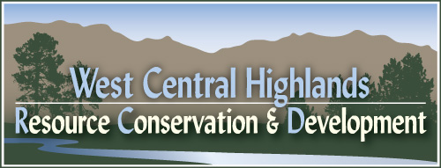

WEST CENTRAL HIGHLANDS
RESOURCE CONSERVATION & DEVELOPMENT COUNCIL

1805 Highway 16, P O Box 95, Emmett, ID 83617
Phone (208) 365-3533 * Fax (208) 365-7183 * E-Mail wchrcd@idahorcd.org

PROJECT PROPOSAL

Measure #

Name of Proposal:

Date: | County: | Location:

Sponsor:

Name of Contact Person:

Address: | Phone: 208/

Description of Present Condition & Need:

Benefits Expected :

Progress to Date:

Technical Assistance Needed:
Estimated Financial Assistance Needed:
Total Estimated Cost of Proposal:
Time Frame for Proposed Action:

PROJECT SPONSORS

Organization | Organization
Signature and Title | Signature and Title
Date Action Taken | Date Action Taken

Organization | Organization
Signature and Title | Signature and Title
Date Action Taken | Date Action Taken

Chairman, West Central Highlands RC&D Council
Date Accepted by RC&D Executive Committee

